**Exercise 5: Configuring the Spring IoC Container**

**Scenario:**

**The library management application requires a central configuration for beans and dependencies.**

**Steps:**

**1. Create Spring Configuration File:**

**o Create an XML configuration file named applicationContext.xml in the src/main/resources directory.**

**Ans.**

Step 1: -Right-click on src/main/resources.

Step 2: - Select New > Other... > General > File and click Next.

Step 3: -Enter the file name as applicationContext.xml and then click of Finish.



**o Define beans for BookService and BookRepository in the XML file.**

**Ans.**

Open the applicationContext.xml file and type the following configuration.

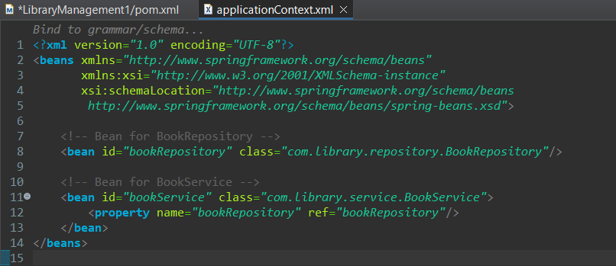

**2. Update the BookService Class:**

**o Ensure that the BookService class has a setter method for BookRepository.**

**Ans.**

Step 1: -Right-click on src/main/java and select New > Package.

Step 2: - Enter com.library.service as the package name and click Finish.

Step 3: - Right-click on the newly created package and select New > Class.

Step 4: - Enter BookService as the class name and click Finish.

BookService

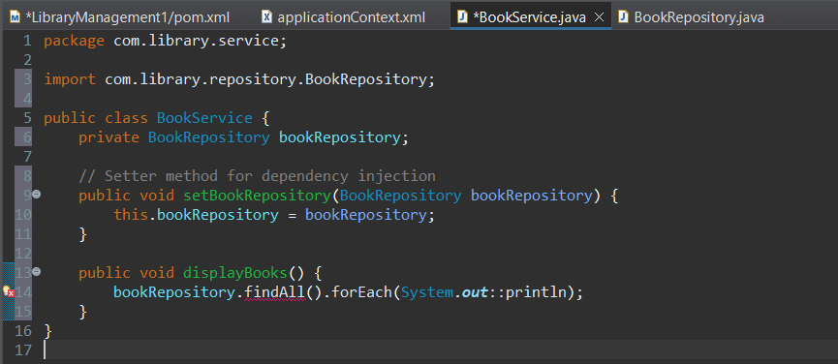

Step 1: -Right-click on src/main/java and select New > Package.

Step 2: -Enter com.library.repository as the package name and click Finish.

Step 3: -Right-click on the newly created package and select New > Class.

Step 4: -Enter BookRepository as the class name and click Finish.

BookRepository

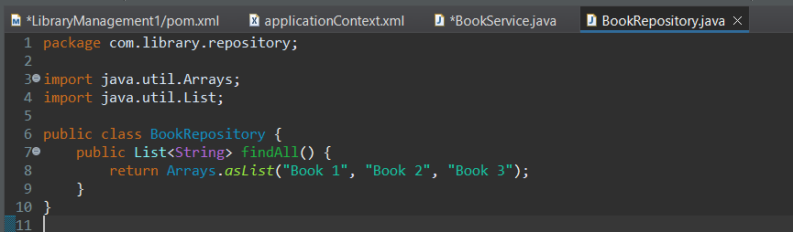

**3. Run the Application:**

**o Create a main class to load the Spring context and test the configuration.**

**Ans.**

Step 1: -Create a package named com.library.main

Step 2: -Create a main class named “LibraryManagementApplication” to load the Spring context and test the configuration.

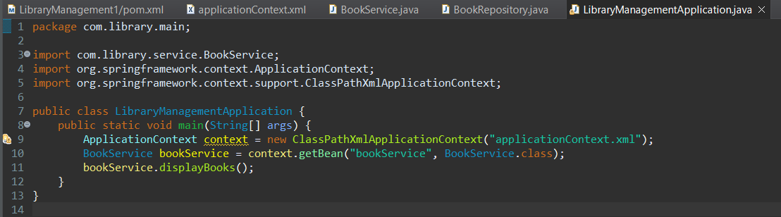

**Output: -**

